(Approx. 1,359 words)

Image Processing Software, Part 2
By Dick Maybach, Member,
Brookdale Computer Users’ Group, NJ
March 2014 issue, BUG Bytes
www.bcug.com / n2nd (@) att.net

In the first article (February 2014 newsletter available at www.bcug.com) we discussed photo retouching using GIMP (GNU Image Processing Program). However, GIMP does not develop raw files; for that you need a program such as RawTherapee. Why would you want to bother with this extra step? In the picture inside a church, the frame on the left is the JPEG image as produced by my camera, while the one on the right is the same image, but I used RawTherapee to process it from a raw file. (I have my camera set up to save every picture as both a JPEG and a raw image and decide what processing to use after I see the results.) This example shows one advantage of working with a raw images. In the JPEG, the roof is essentially black with no visible detail, while in the processed raw image, the details are visible. This is not a simple exposure compensation, as you can see by noting that the highlights in the two images (for example as seen through the open door on the right) have about the same brightness. While adjusting the brightness, I also compensated for the perspective distortion resulting from the wide-angle lens. As a result, the image on the right is much closer to what your eye would see. (The changes here are modest, in an attempt to keep the result realistic. You can easily go off the rails and produce results that belong in a comic strip.) The improvement is possible because the camera records 12 bits per pixel per color, while a JPEG image has only 8. In other words, the raw image has 16 times the dynamic range of the JPEG one. In photo terms, this means that the raw image has two to three more f-stops of range that a corresponding JPEG.
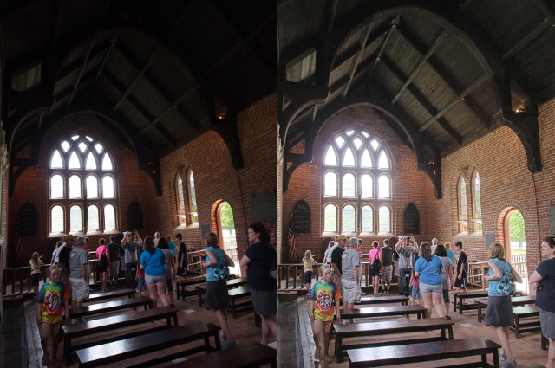
The screen-shot below shows an image being processed by RawTherapee (http://rawtherapee.com/ for Linux, OS X, and Windows). The panel on the right shows the tools availalbe, and these are grouped with tabs. The color adjustment tab has been selected and the white balance tool within it. From left to right the tabs are exposure, detail, color, transform, raw processing, and metadata. Histograms for luminance, and the three primary colors are visible at the top of this panel. The left panel shows the history of the changes, and the center one the current state of the image. If you look carefully, you will see a button on the bottom, just to the left of the orange "Ready" button. Clicking this develops the image and sends it to GIMP as a 16-bit TIFF file. (As I noted in the previous article, the current version of GIMP is capable of only 8-bit processing, so it immediately converts the file to 8-bit TIFF. Hopefully, this butchering will stop with the next version of GIMP.) The next button to the left outputs a JPEG, TIFF, or PNG file directly. I frequently skip GIMP altogether as RawTherapee can often do all the processing I need. RawTherapee is a non-destructive editor; that is, it makes no changes to the image file. Instead, it creates a separate script file that specifies the processing to be done when the raw image is developed. The processing occurs in the order the program deems optimal. As a result, the order in which you perform your editing is unimportant. This is much different than with a program such as GIMP, which changes the image directly in sync with what you do. In the latter case, the order of the editing steps is quite important. RawTherapee requires some persistence to master, partly because it has no help file. Expect to spend some time reading the manual and searching the Web for examples before you become comfortable with it. Finally, although it should run on a 32-bit operating system without difficulty, a 64-bit one is recommended.

RawTherapee has a unique ability to correct for lens distortion. When your camera saves an image in raw format, the file includes a JPEG thumbnail in which the lens distortion has been corrected (providing that if your camera has a removable lens, it's compatible with the camera). The program uses the thumbnail to correct any distortion in the raw image. All other programs that incorporate automatic distortion correction, including Photoshop, use databases, and these don't cover all combinations of cameras and lenses. Indeed, RawTherapee can use the same Adobe camera and lens profiles used by Photoshop, but it is a non-trivial process to adapt them.
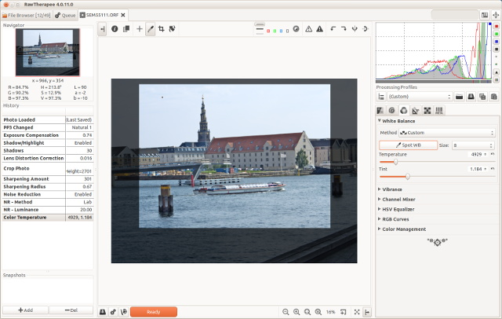
Lightzone (http://www.lightzoneproject.org/ for Linux, OS X, and Windows) is a raw developer with a much different approach. For one, you can specify only a portion of the image for a particular processing step, while RawTherapee always works on the entire image. It can also show you which portions of the image have similar luminosities, which is frequently helpful. The screen-shot below shows an image being edited in LightZone. In the right-hand panel, the icons below the thumbnail bring up windows, a new one each time you click on an icon. Each window is one application of an editing tool, which can apply to the whole image or just a portion. If you delete a window, the changes you made using that step are also discarded. When you develop the image, the processing is done in the same order as the tool windows, so unlike RawTherapee, their order can be important. You can reorder the processing by drag-and-drop moving of the tool windows. You can also change the way in which the effects of each tool are combined in the final image. The left-hand panel shows the editing history. Here, I've adjusted the white balance, applied the relight tool (which lightened the shadows and darkened the highlights) and further lightened the shadows. Then I used the color selector to select the very bright areas (the window and the sun-lit highlights on the table) and reduced the luminosity of only those regions. Finally, I rotated the image. All this takes longer to describe than to do. The screen-shot shows a region selected based on its luminosity, but I could have based it on color, or just by drawing an outline.

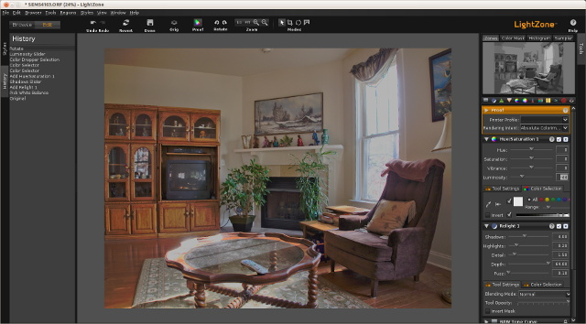
Like RAWTherapee, LightZone has several pre-defined styles, and often applying one of these is the only thing you need do to obtain a satisfactory result. Unlike RawTherapee and UFRaw, LightZone has no provisions for correcting distortions. (If you look carefully at the window frame and the bookcase, you can see some curvature, which results from my particular lens, a wide-range zoom. Better lenses have less distortion and some cameras correct for it in their raw images.)

To get the best results from LightZone you must start from a raw image, as JPEG has discarded much of the photo's dynamic range. Since the program can't correct lens distortion, you would pass the developed image file to GIMP in TIFF format (to avoid degrading it with JPEG compression). There, you would correct he image in GIMP, perhaps by comparing it to a JPEG version of a photo as processed by your camera.

The combination of GIMP, RawTherapee, and LightZone will provide the tools to do almost all your image processing. I've introduced these because they have good reputations and I'm familiar with them. However, an Internet search using “image processing software” will reveal dozens of alternatives, both free and commercial.

References

- Montabone: Beginning Digital Image processing Using Free Tools for Photographers – provides a good overview of the tools I've discussed, although the book is less helpful than it could be as all the example images are in black and white.
- http://www.cambridgeincolour.com/ – contains many very valuable tutorials on photography and image processing. If you check only one photo Web site, this should be the one.
- Make a search for "RawTherapee 4 User Manual" to find a very good manual (hosted on Google Books). This is essential as the program has no help feature
- http://sunburntandinneedofashave.blogspot.com/2010/03/lightzone-beginners-tutorial-well-sort.html – will get you started with LightZone, although the program does have very good help.
- . help.although the program does have very good hel. very good help features.

